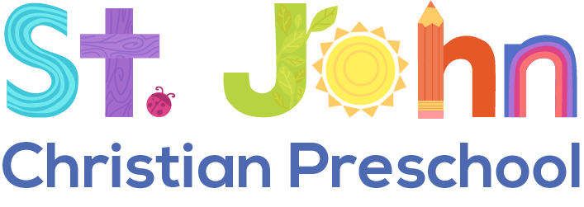

And Kindergarten
6135 Rings Rd., Dublin, OH 43016 stjohndublin.org
2023-2024 School Year

Why St. John Christian Kindergarten?
Christian Education – Christ-centered education including Bible stories, prayer, chapel, and opportunities to serve others

Ohio Approved Curriculum – Curriculum that meets or exceeds Ohio Kindergarten Standards in all areas of development

Small Class Size – Class size capped at 18 students

Variety of Options
Half-Day 9:00 AM – 12:00 PM* $3990
Half-Day with Lunch 9:00 AM – 1:00 PM $4410
Full-Day 9:00 AM – 3:00 PM $5670

Monthly Payment Plans Available – Scholarship Information Available
Option to move from half-day to full-day program during the school year
*Includes 75 additional hours above traditional 2.5 hour half-day programs

kindergarten@stjohndublin.org 614-889-5893
Bonnie Stottlemyer, Administrator

